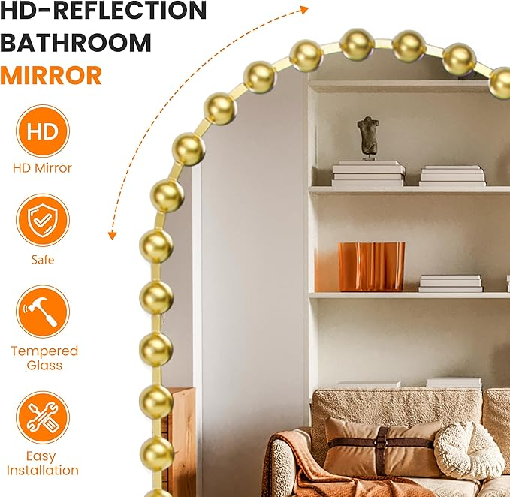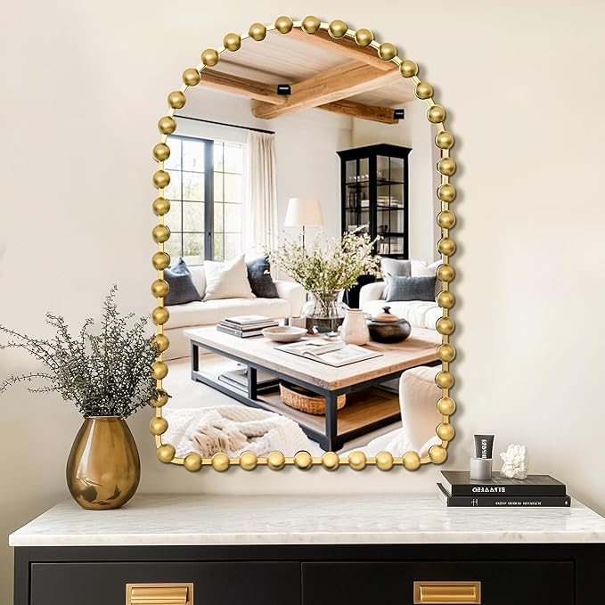



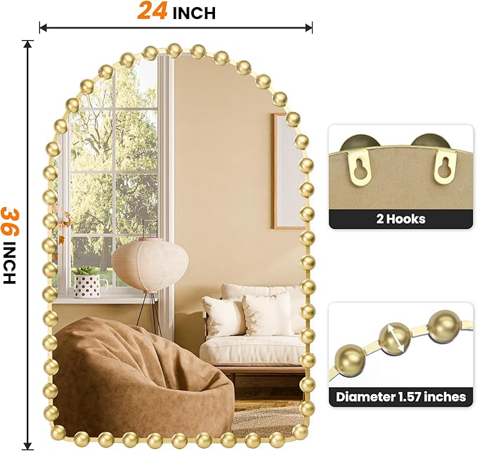

Arched Wall Mirror with Metal Beaded Frame, 24"x36" Antique Gold Decorative Wall Mirror for Bathroom, Bedroom, Living Room, Entryway

**PRODUCT DESCRIPTION:**

|  |  |
| --- | --- |
| Brand | TRAHOME |
| Room Type | Bathroom |
| Shape | Arched |
| Product Dimensions | 36"L x 24"W |
| Frame Material | Iron |

Color: Gold

**About this item**

* Unique Handcrafted Design: This 36"x24" arched wall mirror features a stunning beaded metal frame in an antique gold finish. The solid bead design and rounded arch shape add an elegant and artistic touch to your space.
* HD Clarity & Explosion-Proof Glass: Made with upgraded 4MM high-definition silver glass, this mirror provides a clear, distortion-free reflection. The explosion-proof film enhances safety, preventing shattering and keeping your family safe in case of accidental damage
* Versatile & Functional Mirror: This gold wall mirror is ideal for various spaces, including bathrooms, living rooms, bedrooms, and entryways. It can be mounted vertically with the pre-installed reinforced hooks or leaned against the wall for a more casual, decorative look. It is perfect as a vanity mirror, makeup mirror, or mantelpiece accent.
* Durable & Anti-Corrosion Frame: Crafted with heavy-duty cast iron and finished in vintage gold, this mirror is anti-scratch, corrosion-resistant, and non-rusting. The MDF backing provides additional support, ensuring durability and longevity, even in humid environments like bathrooms.
* Easy Installation & Ideal Gift: Featuring an anti-corrosive hanging system and two pre-installed hooks, this mirror is a breeze to mount vertically. Screws and anchors are included for easy installation. This stylish mirror makes a perfect gift for a housewarming, holiday, or special occasion.